Brian Engel

Module 4 Assignment

While I like the steam app, I would design a few things differently. On the top menu bar, I would leave just the search and help features, and get rid of the options beneath it of menu wish list and wallet. These make no sense to me because you can get to them through the other options in the bottom menu and are not important at all. If you look at the second line of actual content under featured & recommended, you can see that this is a list that extends off the side of the screen that you have to scroll to see. This would be fine on a desktop since you have a lot more width to work with and a mouse, or possibly a tablet, but doesn’t seem to be ideal for a phone type device. I would change this to a list that shows 2 items per line and has 2 lines and a see more button underneath, at least for devices that are under a certain width. This way you don’t have to scroll sideways, and the content is always visible. I like the bottom menu and would leave that as is.

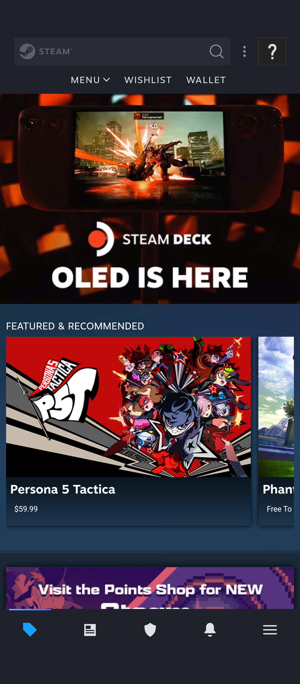

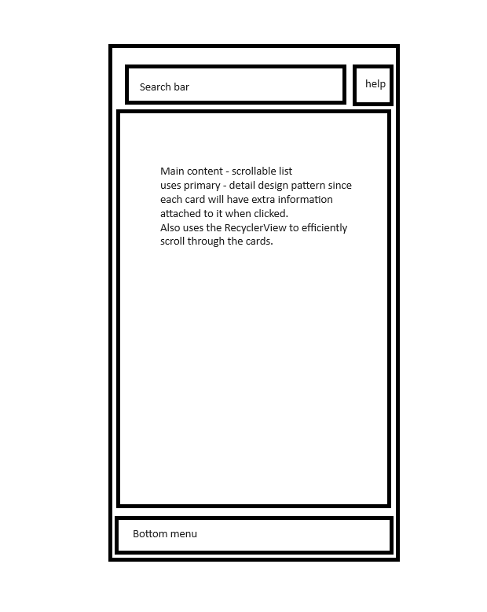

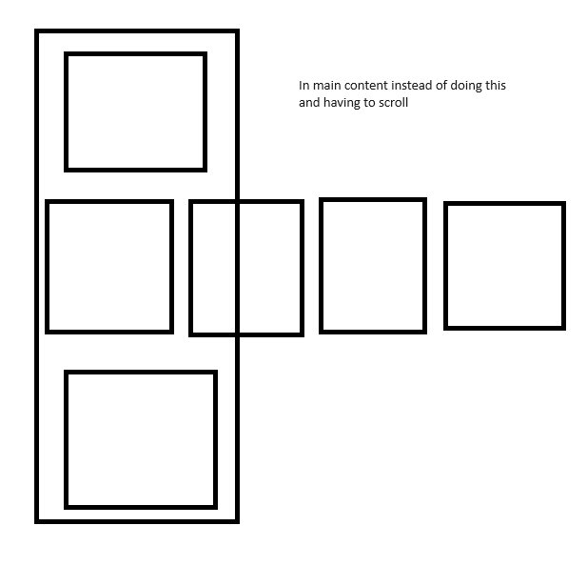

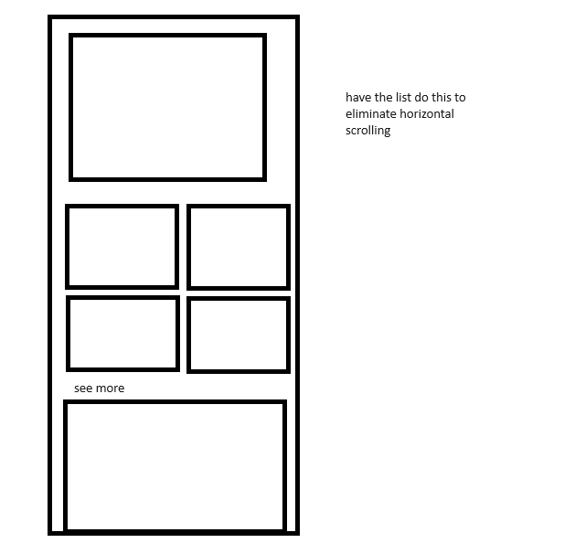

The reason behind my design changes is because users scan using a F pattern. 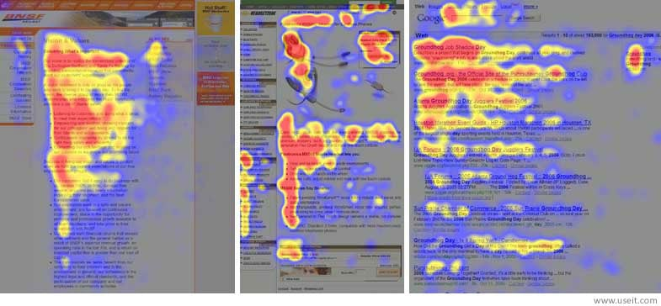

This image shows what the users eye focus on when scanning a web page (Pernice). Stuff on the right and bottom gets significantly less attention, even without having to scroll. While not having to scroll down would be next to impossible, we can at least take out horizontal scrolling.

Pernice, Kara. F-Shaped Pattern of Reading on the Web: Misunderstood, But Still Relevant (Even on Mobile). November 12, 2017. https://www.nngroup.com/articles/f-shaped-pattern-reading-web-content/